*Exercise:4*

*Date:12/10/2020*

*AIM:*

*To write a python program to print a single string from two set of strings received from the user and swap the first two characters of each string.*

*PROGRAM:*

*def convert(s):*

*new=””*

*for x in s:*

*new+=x*

*return new*

*a=input()*

*b=input()*

*s1=a.strip()*

*s2=b.strip()*

*if(len(s1)>=2 and len(s2)>=2):*

*t1=list(s1)*

*t2=list(s2)*

*c1=t1[0]*

*c2=t1[1]*

*t1[0]=t2[0]*

*t1[1]=t2[1]*

*t2[0]=c1*

*t2[1]=c2*

*s1=convert(t1)*

*s2=convert(t2)*

*print(s1,” “,s2”)*

*else:*

*print(“Invalid”)*

*LINK:*

[*http://103.53.53.18/mod/vpl/forms/edit.php?id=234&userid=1794#*](http://103.53.53.18/mod/vpl/forms/edit.php?id=234&userid=1794)

*OUTPUT:*

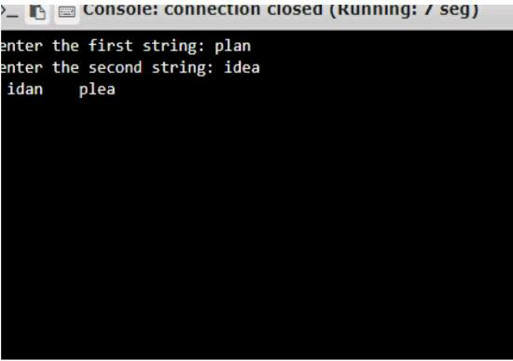

*RESULT:*

*The program to print the single string from two set of strings received from the user and swap the first two characters of each string is executed and the output is verified*